Angular 2 End-to-end
Setting up the project

Vetsina infa je v komnetarich v kodu – není zde ale dobra architektura a kvalita kodu

Budeme budovat appku
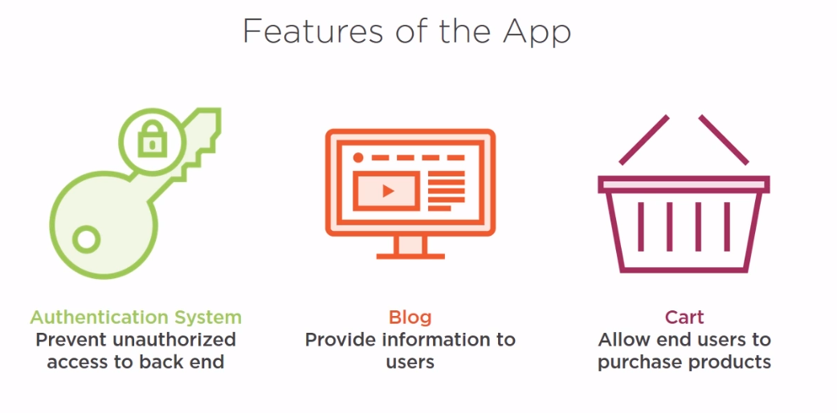
Na host použijeme Firebase – použijeme i Firebase authentification
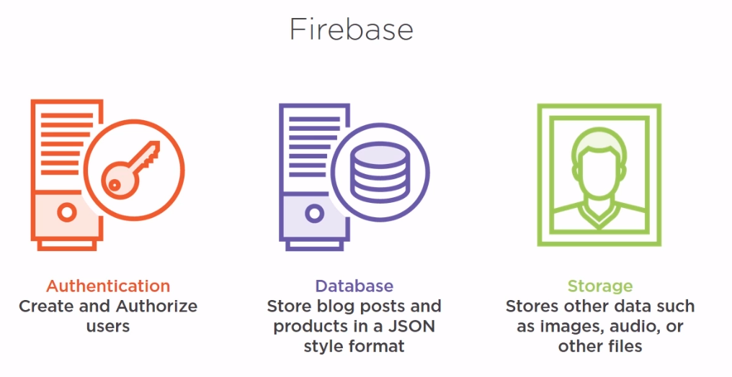
Tsconfig.json
{
"compilerOptions": {
"target": "es5",
"lib": ["es2017", "dom"],
"module": "commonjs",
"moduleResolution": "node",
"sourceMap": true,
"emitDecoratorMetadata": true, //musime implementovat protoze Angular 2 pouziva
"experimentalDecorators": true,//musime implementovat protoze Angular 2 pouziva
"removeComments": false,
"noImplicitAny": true,
"suppressImplicitAnyIndexErrors": true
}
}

Webpack basics
Modular bundeler
Alternativa to system.js
Zvladne vice typu files

webpack.common.js – zakladni nastaveni webpacku bez pridanych pluginu
var webpack = require('webpack');
var HtmlWebpackPlugin = require('html-webpack-plugin');
var ExtractTextPlugin = require('extract-text-webpack-plugin');
var helpers = require('./helpers');

module.exports = {
entry: {
'polyfills': './src/polyfills.ts',
'vendor': './src/vendor.ts', //obsahuje vsechny zakladni moduly co potrebujeme, plus veci jako jQuery atd
'app': './src/main.ts'
},

resolve: {
modules: ['node_modules'],
extensions: ['.js', '.ts', '.scss']
},

module: {
rules: [
{
test: /\.ts$/,
loaders: ['awesome-typescript-loader', 'angular2-template-loader']
},
{
test: /\.html$/,
loader: 'html-loader'
},
{
test: /\.(png|jpe?g|gif|svg|woff|woff2|ttf|eot|ico)$/,
loader: 'file-loader?name=assets/[name].[hash].[ext]'
},
{
test: /\.scss$/,
exclude: helpers.root('src', 'app'),
//loader: ExtractTextPlugin.extract('style-loader', 'css-loader!sass-loader')
use: ExtractTextPlugin.extract({
fallback: "style-loader",
use: "css-loader!sass-loader",
})
},
{
test: /\.css$/,
include: helpers.root('src', 'app'),
loader: 'raw-loader'
}
]
},

plugins: [
new webpack.optimize.CommonsChunkPlugin({
name: ['app', 'vendor', 'polyfills']
}),

new HtmlWebpackPlugin({
template: 'src/index.html'
})
]
};

webpack.dev.js
var webpackMerge = require('webpack-merge');
var ExtractTextPlugin = require('extract-text-webpack-plugin');
var commonConfig = require('./webpack.common.js');
var helpers = require('./helpers');

module.exports = webpackMerge(commonConfig, {
devtool: 'cheap-module-eval-source-map',

output: {
path: helpers.root('dist'),
publicPath: 'http://localhost:8080/',
filename: '[name].js',
chunkFilename: '[id].chunk.js'
},

plugins: [
new ExtractTextPlugin('[name].css')
],

devServer: {
historyApiFallback: true,
stats: 'minimal'
}
});

Setting up Authentication
Budeme používat FireBase
Admin.module.ts
import { NgModule } from '@angular/core';
import { CommonModule } from '@angular/common';
import { RouterModule, Routes } from '@angular/router';
import { FormsModule } from '@angular/forms';

import { AdminComponent } from './adminComponent/admin.component';
import { AdminMenuComponent } from './adminMenu/admin-menu.component';
import { LoginComponent } from './login/login.component';
import { SignUpComponent } from './signUp/sign-up.component';

import { UserService } from './adminShared/user.service';

const AdminRoutes: Routes = [
{
path: 'admin',
component: AdminComponent,
children: [
{ path: 'login', component: LoginComponent },
{ path: 'signup', component: SignUpComponent },
{ path: '', component: AdminMenuComponent, canActivate: [UserService] }//canActivate rika kde se bude overovat ze mame pro tuto routu prava
]
},
];
@NgModule({
imports: [
CommonModule,
FormsModule,
RouterModule.forChild(AdminRoutes)
],
exports: [
RouterModule
],
declarations: [
AdminComponent,
AdminMenuComponent,
LoginComponent,
SignUpComponent
],
providers: [
UserService,
]
})
export class AdminModule {}

user.service.ts
import { Injectable } from '@angular/core';
import {
CanActivate,
Router,
ActivatedRouteSnapshot,
RouterStateSnapshot
} from '@angular/router';
import * as firebase from 'firebase';

@Injectable()
export class UserService implements CanActivate {
userLoggedIn: boolean = false;
loggedInUser: string;
authUser: any;

constructor( private router: Router ) {
//inicializujeme Firebase
firebase.initializeApp({
apiKey: "API Key Goes Here",
authDomain: "Auth Domain Goes Here",
databaseURL: "Database URL goes here",
storageBucket: "Storage bucket info goes here",
messagingSenderId: "Message Sender ID goes here"
})
}

canActivate(route: ActivatedRouteSnapshot, state: RouterStateSnapshot): boolean {
//overujeme routy zda mame pristup
let url: string = state.url;
return this.verifyLogin(url);
}

verifyLogin(url: string): boolean {
if (this.userLoggedIn) { return true; }

this.router.navigate(['/admin/login']);
return false;
}

register(email: string, password: string){
firebase.auth().createUserWithEmailAndPassword(email, password)
.catch(function(error) {
alert(`${error.message} Please Try Again!`);
});
}

//vola se z jednotlivych component.ts jako akce na klick
verifyUser() {
this.authUser = firebase.auth().currentUser;
if (this.authUser) {

alert(`Welcome ${this.authUser.email}`);
this.loggedInUser = this.authUser.email;
this.userLoggedIn = true;
this.router.navigate(['/admin']);
}
}

login(loginEmail: string, loginPassword: string) {
firebase.auth().signInWithEmailAndPassword(loginEmail, loginPassword)
.catch(function(error) {
alert(`${error.message} Unable to login. Try again!`);
});
}

logout(){
this.userLoggedIn = false;
firebase.auth().signOut().then(function() {
alert(`Logged Out!`);

}, function(error) {
alert(`${error.message} Unable to logout. Try again!`);
});
}

}

OnInit()
OnInit je metoda, která exetuje jiné metody když je componenta vytvorena

Setting up Blog System
Vytvoříme blog.ts
export class Blog {
constructor(
public title: string,
public content: string,
public imgTitle?: string,
public img?: any,
public id?: string
){}

}

Pote BlogAdminService.ts
import { Injectable } from '@angular/core';
import * as firebase from 'firebase';
import { Blog } from '../adminShared/blog';

@Injectable()

export class BlogAdminService {

createPost(post: Blog){
//reference na firebase storage
let storageRef = firebase.storage().ref();
//vytvorime si cestu kam budeme uklada obrazky
storageRef.child(`images/${post.imgTitle}`).putString(post.img, 'base64')
.then((snapshot) => {
//ziskame cestu k obrazku a nasledne podle toho ulozime blog post
let url = snapshot.metadata.downloadURLs[0];
let dbRef = firebase.database().ref('blogPosts/');
let newPost = dbRef.push();
//zapiseme data do firebase pomoci set
newPost.set ({
title: post.title,
content: post.content,
imgTitle: post.imgTitle,
img: url,
id: newPost.key
});
})
.catch ((error)=>{
alert(`failed upload: ${error}`);
});
}

editPost(update: Blog){
let dbRef = firebase.database().ref('blogPosts/').child(update.id)
.update({
title: update.title,
content: update.content
});
alert('post updated');
}

removePost(deletePost: Blog){
let dbRef = firebase.database().ref('blogPosts/').child(deletePost.id).remove();
alert('post deleted');
let imageRef = firebase.storage().ref().child(`images/${deletePost.imgTitle}`)
.delete()
.then(function() {
alert(`${deletePost.imgTitle} was deleted from Storage`);
}).catch(function(error) {
alert(`Error - Unable to delete ${deletePost.imgTitle}`);
});
}

}

Creating Pipe
trunc.pipe.ts
import { Pipe, PipeTransform } from '@angular/core';

@Pipe({name: 'truncate'})

export class TruncatePipe implements PipeTransform {
transform(value: string, chars: number): string {
let text = `${value.substring(0, chars)} ...`;
return text;
}
}

</div>
<div class="media-object-section main-section">
<h4>{{posts.title}}</h4>
<p>{{posts.content | truncate:140}}</p>
<div class="button-group align-center">
<a class="button" (click)="editPost(posts)" >Edit</a>
<a class="button alert" (click)="deletePost(posts)">Delete</a>
</div>
</div>

Setting up the Shopping Cart
product.ts
export class Product {
constructor(
public name: string,
public description: string,
public imgTitle: string,
public img: any,
public price: number,
public id?: string
){}
}

product-admin.service.ts
import { Injectable } from '@angular/core';
import * as firebase from 'firebase';
import { Product } from '../adminShared/product';

@Injectable()

export class ProductAdminService {

createProduct(prod: Product){
let storageRef = firebase.storage().ref();
storageRef.child(`product_images/${prod.imgTitle}`).putString(prod.img, 'base64')
.then((snapshot) => {
let url = snapshot.metadata.downloadURLs[0];
let dbRef = firebase.database().ref('products/');
let newProd = dbRef.push();
newProd.set ({
name: prod.name,
desc: prod.description,
imgTitle: prod.imgTitle,
img: url,
price: prod.price,
id: newProd.key
});
})
.catch ((error)=>{
alert(`failed upload: ${error}`);
});
}

editProduct(update: Product){
let dbRef = firebase.database().ref('products/').child(update.id)
.update({
name: update.name,
desc: update.description,
price: update.price
});
alert('product updated');
}

removeProduct(deleteProduct: Product){
let dbRef = firebase.database().ref('products/').child(deleteProduct.id).remove();
alert('product deleted');
let imageRef = firebase.storage().ref().child(`product_images/${deleteProduct.imgTitle}`)
.delete()
.then(function() {
alert(`${deleteProduct.imgTitle} was deleted from Storage`);
}).catch(function(error) {
alert(`Error - Unable to delete ${deleteProduct.imgTitle}`);
});
}
}

